Birla Institute of Technology & Science, Pilani
Work Integrated Learning Programmes Division
First Semester 2025-2026

Mid-Semester Test
(EC-2 Regular)

Course No. : SE ZG568 / SS ZG568
Course Title : Applied Machine Learning
Nature of Exam : Closed Book
Weightage : 30%
No. of Pages = 2

No. of Questions = 3
Duration : 2 Hours
Date of Exam : 20/09/2025 (AN)
Note to Students:
- Please follow all the Instructions to Candidates given on the cover page of the answer book.
- All parts of a question should be answered consecutively. Each answer should start from a fresh page.
- Assumptions made if any, should be stated clearly at the beginning of your answer.

Marks 10
- In a Covid test of 1000 patients, there were 45 positive tests, of which 30 patients had covid and 15 were falsely tested positive. Of the 955 negative tests there were 5 that were incorrect, these patients had covid but were tested negatively. Draw the confusion matrix and calculate the accuracy, precision, recall and F1 score from the matrix.

Marks 6
- State and explain three types of Gradient descent.

Marks 6
- Can you explain the difference between a high-bias model and a high-variance model? How will you identify them. How will you fix the issue?

Marks 4
- Calculate the probability of passing for a student who studied for 33 hours. Given Θ₀=-64, Θ₁=2.
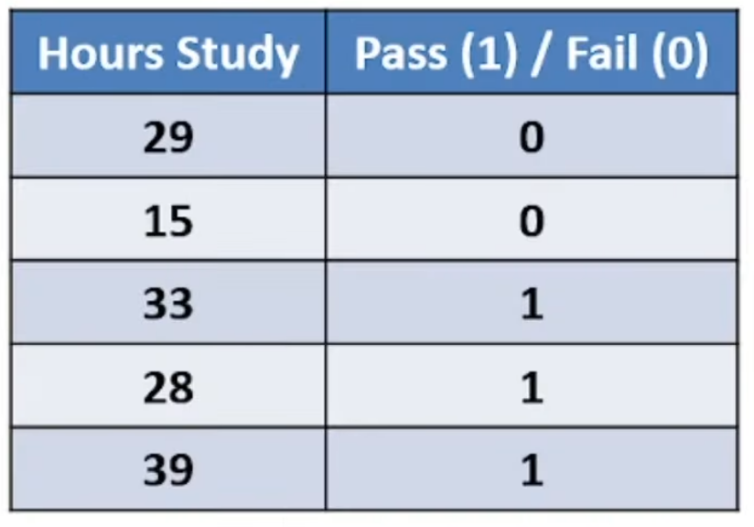

Marks 4
- Consider the following three objective functions:
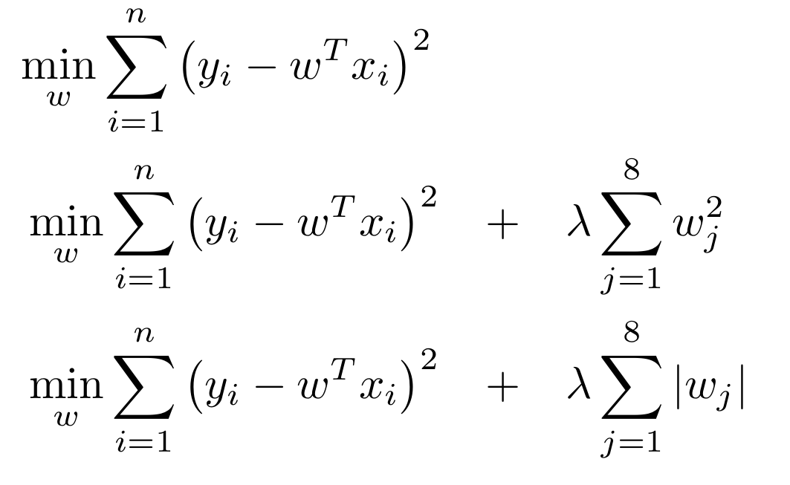
Identify the regularization terms in the objective functions above. Explain the consequence of large values of λ on the model.

